EMERGING METHODS FOR EARLY DETECTION OF FOREST FIRES **PROJECT REPORT**

*Submitted By*

**TEAM ID – PNT2022TMID44068**

1. **S. KAILASH**
2. **P. SRI KRISHNAN**
3. **R. KOWSHIK**
4. **M. CHANDRU**

# LIST OF TABLE

|  |  |  |
| --- | --- | --- |
| **S.NO.** | **TITLE** | **PAGE NO.** |
| **1** | **INTRODUCTION** | **3** |
| **1.1** | **Project Overview** | **3** |
| **1.2** | **Purpose** | **4** |
| **2** | **LITERATURE SURVEY** | **5** |
| **2.1** | **Existing problem** | **5** |
| **2.2** | **References** | **5** |
| **2.3** | **Problem Statement Definition** | **6** |
| **3** | **IDEATION & PROPOSED SOLUTION** | **7** |
| **3.1** | **Empathy Map Canvas** | **7** |
| **3.2** | **Ideation & Brainstorming** | **7** |
| **3.3** | **Proposed Solution** | **8** |
| **3.4** | **Problem Solution fit** | **10** |
| **4** | **REQUIREMENT ANALYSIS** | **11** |
| **4.1** | **Functional requirement** | **11** |
| **4.2** | **Non-Functional requirements** | **12** |
| **5** | **PROJECT DESIGN** | **13** |
| **5.1** | **Data Flow Diagrams** | **13** |
| **5.2** | **Solution & Technical Architecture** | **14** |
| **5.3** | **User Stories** | **16** |
| **6** | **PROJECT PLANNING & SCHEDULING** | **17** |
| **6.1** | **Sprint Planning & Estimation** | **17** |
| **6.2** | **Sprint Delivery Schedule** | **17** |
| **6.3** | **Reports from JIRA** | **18** |
| **7** | **CODING & SOLUTIONING** | **18** |
| **7.1** | **Feature 1** | **18** |
| **7.2** | **Feature 2** | **19** |
| **8** | **TESTING** | **20** |
| **8.1** | **Test Cases** | **20** |
| **8.2** | **User Acceptance Testing** | **20** |
| **9** | **RESULTS** | **21** |
| **9.1** | **Performance Metrics** | **21** |
| **10** | **ADVANTAGES & DISADVANTAGES** | **22** |
| **11** | **CONCLUSION** | **22** |
| **12** | **FUTURE SCOPE** | **23** |
| **13** | **APPENDIX** | **24** |

**Project Report**

**EMERGING METHODS FOR EARLY DETECTION OF FOREST FIRES**

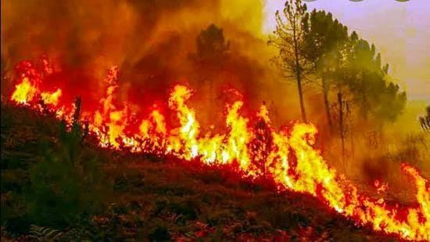

1. **INTRODUCTION**

Forest fires are occurring throughout the year with an increasing intensity in the summer and autumn periods. These events are mainly caused by the actions of humans, but different nature and environmental phenomena, like lightning strikes or spontaneous combustion of dried leafs or sawdust, can also be credited for their occurrence. Regardless of the reasons for the ignition of the forest fires, they usually cause devastating damage to both nature and humans. Forest fires are also considered as a main contributor to the air pollution, due to the fact that during every fire huge amounts of gases and particle mater are released in the atmosphere. To fight forest fires, different solutions were employed throughout the years. They ware primary aimed at the early detection of the fires.

# Project Overview

The simplest of these solutions is the establishment of a network of observation posts - both cheap and easy to accomplish, but also time-consuming for the involved people. The constant evolution of the information and communication technologies has led to the introduction of a new generation of solutions for early detection and even prevention of forest fires. ICT-based networks of cameras and sensors and even satellite-based solutions were developed and used in the last decades. These solutions have greatly decreased the direct involvement of humans in the forest fire detection process, but have also proven to be expensive and hard to maintain. In this paper we will discuss and present two different emerging solutions for early detection of forest fires. The first of these solutions involves the use of unmanned aerial vehicles (UAVs) with specialized cameras. Several different scenarios for the possible use of the drones for forest fire detection will be presented and analysed, including a solution with the use of a combination between a fixed-wind and a rotary-wing UAVs. In the next chapter of the paper, we will present and discuss the possibilities for development of systems for early forest fire detection using LoRaWAN sensor networks and we will analyse and present some of the hardware and software components for the realisation of such sensor networks. The paper will also provide another point-of-view, which will present the involvement of students in the development and in the use of both systems and we will analyze the advantages and the benefits, which the students will gain from their work on and with these solutions.

# 1.2 Purpose

Detection of forest fire and smoke in wild land areas is done through remote sensing-based methods such as ***satellites, high-resolution static cameras fixed on the ground, and unmanned aerial vehicles (UAVs).***

1. Images that are captured through the satellites have poor resolution, and hence, it becomes difficult to detect the particular area.
2. Continuous information about the status of the forest could not be obtained due to the restrictions in the monitoring of forests.
3. Weather might not be stable in all situations as it might vary, and thus, it results in the collection of noisy images.
4. **LITERATURE SURVEY**

|  |  |  |  |  |
| --- | --- | --- | --- | --- |
| **TITTLE** | **AUTHOR AND YEAR** | **PROBLEM PROPOSED** | **LIMITATIONS** | **PROBLEM SOLUTION** |
| Emerging method for early detection of forest fires using unmanned Aerial vehicles and Lorawan sensor network | G.V.Hristor  Diyana kyuchukova  Jordan Raychev(2018) | There are primary aimed at the early detection of the fires | Cause devasting damage to both nature and humans,air pollution,every fire huge amounts of gases released in the atmosphere | The modern IR cameras,unmanned aerial vehicles in fight against the forest fires as replacement of the piloted aircrafts |
| Holistic approach of forest fire protection of split and Dalmatia country of croatia | Darko stipanicev  Ranko vujic(2014) | Dalmatia is highly affected by forest fires during the summer | Rusting in burned down wood mass of 125.000ms which expressed in energy | 1.To animate and make financially attractive for local inhabitants collecting of lopping,chopped wood,dry trundles on the massive scale  2.Thin forests and keep the wooded area as clean and passable as reasonably possible |
| A review on early forest fire detection systems using optical remote sensing | Panagiotis barmpoutis  Konsmas dimitropoulas  Nikos grammalidis(2020) | To review a review of early forest fire detection systems | These are affected by weather conditions and in many cases,their flight time is limited | Early fire detection multispectral imaging systems,terrestrial,aerial,satellite,  Artificial intelligence |
| The influence of climate change on forest fires in Yunnan province,  Southwest china detected by GRACE satellites | Lilu cui  Chaolong yao  Zhengbo zou(2022) | The analyze the influence of climate change on forest tines in Yunnan | Climate change affects the occurrence of forest fines by changing the dryness ob combustibles through temperature,  Precipitation,  Evapotranspiration etc. | The results show that GRACE satellites can detect the influence of climate change on forest fire Yunnan province |
| S-mart forest fires early detection sensory system:  Another approach of utilizing wireless sensor and neutral networks | Hamdy soliman(2010) | This aim of this paper is to implement a forest fire early detection system using small and cheap sensor nodes which can be left unattended | Forest fire all costly and dangerous because they cause extensive damage both to property and human life | The SFFEDSS unit able to not only detect fire but also accurately report the direction of fire progress which is deduced from the wind direction |
| Adoption of image surface parameter under moving edge computing in the construction of mountain fire warning method | Chen cheng  Hui zhou  Danning wang(2020) | The purpose of this study is to project mountain fires based on MEC | Due to the importance of natural and human activities,fire hazard is extremely easy to occur,affects the safety of maintain resource and human life and property | 1.A hierarchical discriminant analysis algorithm for image feature extraction.  2.The design of mobile image acquisition software.  3.Image recognition an optimization algorithm under MEC environment. |
| Natural hazards wildfires | Prof.David(E.Alexander) | Forest and rangeland fires are a source of important eldogical and economic damage. A wildfire burns out of control and threatens people buildings or resources | 1.Lightning strikes  2.Human negligence and vandalism (greatest at the urban rural interface) | Do not burn any materials that are combustible or unusual in nature |

**2.3**

# Problem Statement Definition

* + - Proc essing of symptoms of a forest

Fire

.

* + Processing inputs from various sensors
  + Images of a video are fed to a CNN model to extract high level features.
  + Processing of those images.
  + Alert people as well as animals.

# IDEATION & PROPOSED SOLUTION

* 1. **Empathy Map Canvas & Ideation**

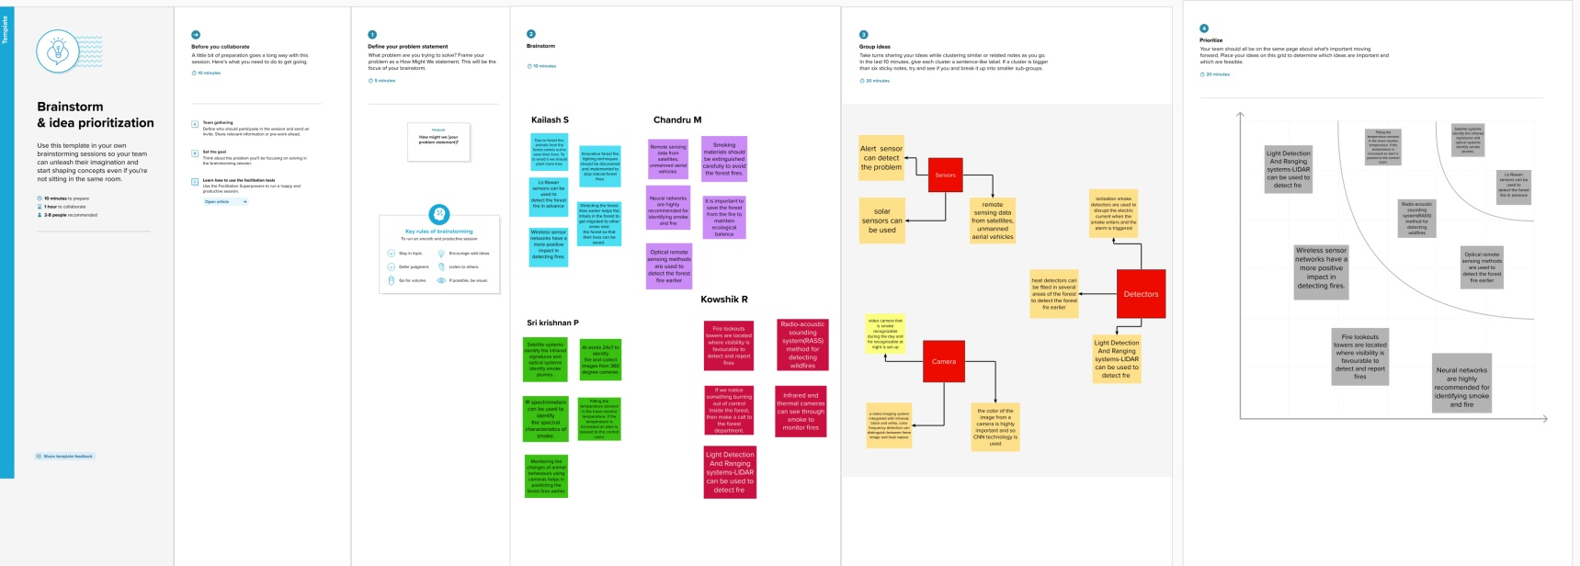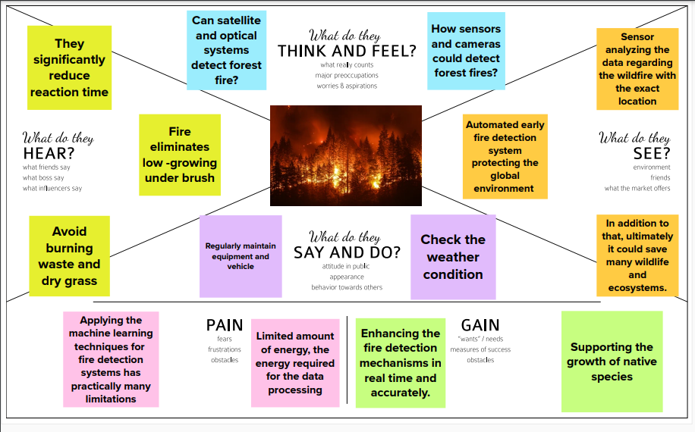

* 1. **PROPOSED SOLUTION:**

|  |  |  |
| --- | --- | --- |
| S.No. | Parameter | Description |
| 1. | Problem Statement (Problem to be solved) | Forest and urban fires are still a serious problem for many countries in the world. The (UAVs), which constantly patrol over potentially threatened by fire areas.  The UAVs also utilize the benefits from Artificial intelligence (AI) and are equipped with on board processing capabilities. |
| 2. | Idea / Solution description | Recent advances in computer vision, machine learning, and remote sensing technologies offer new tools for detecting and monitoring forest fires, while the development of new materials and microelectronics have allowed sensors to be more efficient in identifying active forest  fires. |
| 3. | Novelty / Uniqueness | Permanent monitoring, data collection and processing.  Terrestrial-based early detection systems consist of either individual sensors (fixed, PTZ, or 360◦ cameras) or networks of ground  sensors. |
| 4. | Social Impact / Customer Satisfaction | Growing public alarm at the problem of large- scale forest fires, is evident from an assessment of their past and present repercussions on the  population in general. |
| 5. | Business Model (Revenue Model) | Forest sector has strong importance for the economic, social and environmental issues. Portuguese forestry sector is of great importance for the added value creation, for  the jobs creation. |
| 6. | Scalability of the Solution | There are several factors that affect the evolution of a wild land fire. It is well known that wind is one of the key parameters to understand the forest fire propagation.  Intuitively, the meteorological wind speed tends to drive the main direction of forest fire spread. |

# PROBLEM SOLUTION FIT

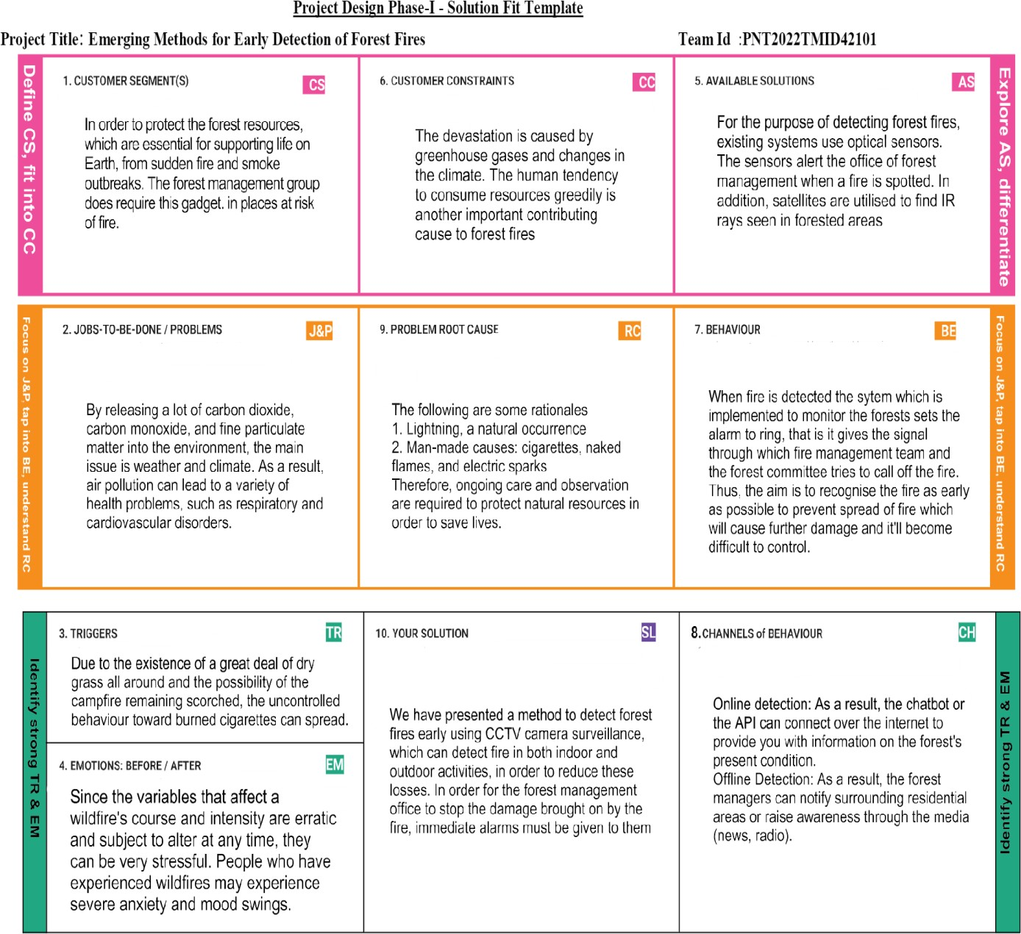

1. **REQUIREMENT ANALYSIS**

# Screenshot 2022-11-18 211701.pngFunctional Requirements

# PROJECT DESIGN

* 1. **Data Flow Diagrams:**
  2. 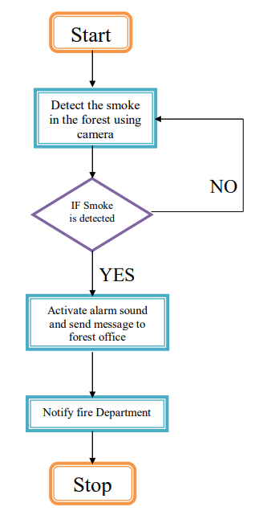
  3. A Data Flow Diagram (DFD) is a traditional visual representation of the information flows within a system. A neat and clear DFD can depict the right amount of the system requirement graphically. It shows how data enters and leaves the system, what changes the information, and where data is stored.

# Solution & Technical Architecture:

* Forest fires are a major environmental issue, creating economic and ecological damage while endangering human lives.
* There are typically about 100,000 wildfires in the United States every year. Over 9 million acres of land have been destroyed due to treacherous wildfires.
* It is difficult to predict and detect Forest Fire in a sparsely populated forest area and it is more difficult if the prediction is done using ground-based methods like Camera or Video-Based approach.
* Satellites can be an important source of data prior to and also during the Fire due to its reliability and efficiency.
* The various real-time forest fire detection and prediction approaches, with the goal of informing the local fire authorities.

# Example - Solution Architecture Diagram:

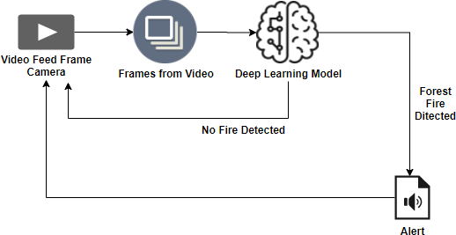

**5.3 User Stories**

Use the below template to list all the user stories for the product.

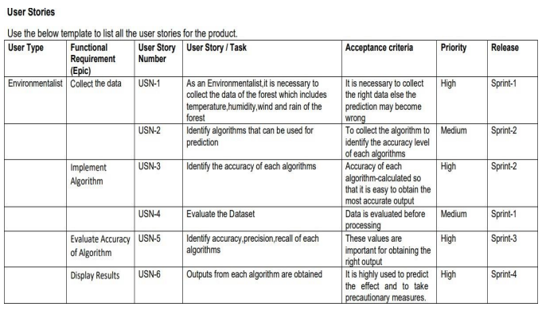

# PROJECT PLANNING & SCHEDULING

* 1. **Sprint Planning & Estimation**

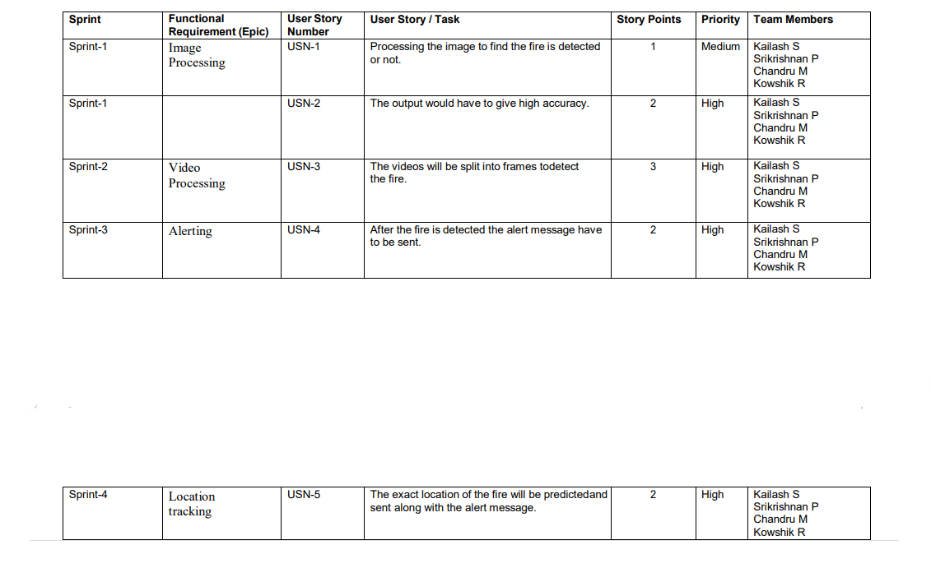

# 2 Sprint Delivery Schedule

# Screenshot 2022-11-18 213502.png

**6.3 Reports from JIRA**

* Packages. Host and manage packages.
* Security. Find and fix vulnerabilities.
* Instant dev environments.
* Copilot. Write better code with AI.
* Manage code changes.
* Issues. Plan and track work.
* Discussions. Collaborate outside of code.

# CODING & SOLUTIONING

imageio==2.6.1 imageio-ffmpeg==0.3.0 Keras==2.1.6 matplotlib==2.2.3 numpy==1.15.1

opencv-contrib-python==3.4.0.12 Pillow==5.2.0

tensorflow==1.5.1

# Feature

# Screenshot 2022-11-18 214406.png

# Screenshot 2022-11-18 214654.png

**OUTPUT**

{'forest': 0, 'with fire': 1}

# TESTING

* 1. **Test Cases**

|  |  |  |  |  |
| --- | --- | --- | --- | --- |
| **Comparison** | **Human based observation** | **Satellite system** | **Optical cameras** | **Wireless sensor**  **networks** |
| Cost | Low | Very high | High | Medium |
| Efficiency and practicality | Low | Low | Medium | High |
| Faulty alarms repetition | Low | Low | Medium | Medium |
| Fire localising accuracy | Low | Medium | Medium | High |
| Detection delay | Long | Very long | Long | Small |
| Fire behaviour information | -- | Yes | -- | Yes |
| Can be used for other purposes | No | Yes | No | Yes |

# User Acceptance Testing

|  |  |  |  |  |  |
| --- | --- | --- | --- | --- | --- |
| **Resolution** | **Severity1** | **Severity2** | **Severity3** | **Severity4** | **Subtotal** |
| By Design | 10 | 4 | 2 | 2 | 19 |
| Duplicate | 1 | 1 | 3 | 0 | 5 |
| External | 2 | 3 | 1 | 1 | 7 |
| Fixed | 11 | 2 | 5 | 20 | 38 |
| Not Reproduced | 0 | 0 | 0 | 0 | 0 |

|  |  |  |  |  |  |
| --- | --- | --- | --- | --- | --- |
| Skipped | 0 | 0 | 1 | 1 | 2 |
| Won'tFix | 0 | 5 | 2 | 1 | 8 |
| Totals | 24 | 14 | 13 | 26 | 77 |

**Testing analysis**

|  |  |  |  |  |
| --- | --- | --- | --- | --- |
| **Section** | **Total Cases** | **Not Tested** | **Fai l** | **Pass** |
| Print Engine | 7 | 0 | 0 | 7 |
| Client Application | 52 | 0 | 0 | 52 |
| Security | 2 | 0 | 0 | 2 |
| Outsource Shipping | 3 | 0 | 0 | 3 |
| Exception Reporting | 9 | 0 | 0 | 9 |
| Final Report Output | 5 | 0 | 0 | 5 |
| Version Control | 2 | 0 | 0 | 2 |

# RESULTS

* 1. **Performance Metrics**

|  |  |  |  |
| --- | --- | --- | --- |
| **S.No** | **Characteristics** | **Description** | **Technology** |
| 1. | Open-Source Frameworks | Python Flask framework is used | Technology of Open source framework |
| 2. | Security Implementations | Mandatory Access Control (MAC) and Preventative  Security Control is used | e.g. SHA 256, Encryptions,IAMControls,  OWASP etc. |
| 3. | Scalable Architecture | High scalability with 3-tier architecture | Web server – HTML ,CSS  ,JavaScript Application server – Python , AnacondaDatabase server  –IBM DB2 |
| 4. | Availability | Use of load balancing to distribute traffic acrossservers | IBM load balancer |
| 5. | Performance | Enhance the performance by using IBM CDN | IBM Content Delivery Network |

# ADVANTAGES & DISADVANTAGES Advantages

* They kill and displace wildlife, alter water cycles and soil fertility, and endanger the lives and livelihoods of local communities.
* They also can rage out of control.
* It allows the person and their family to educate themselves, seek support that works for them, and make informed decisions and plans.
* Low cost to produce and maintain
* Versatile mounting hardware
* Relays vital weather information Limited battery capabilities
* Provides the customer with wildfire detection and monitoring to minimize damage caused by wildfires.
* Small form minimizes wildlife disruption .

# Disadvantages

* Does not have global market penetration like other competitors
* Limited battery capabilities.
* Limited data transfer and communications capabilities
* Will only be available on the west coast at product

# CONCLUSION

The only effective way to minimize damage caused by forest fires is their early detection and fast reaction, apart from preventive measures. Great efforts are therefore made to achieve early forest fire detection, which is traditionally based on human surveillance. Technically more advanced forest fire surveillance systems is based on video camera monitoring units mounted on monitoring spots and distant monitoring from operation center in conjunction with satellite monitoring. Infrared and laser-based systems are more sensitive and they generate less false alarms, but their price is quite high in comparison to video cameras sensitive in visible spectra. In all those systems automatic forest fire detection is based on smoke recognition during the day and flame recognition during the night.

# FUTURE SCOPE

* + Life casualties and avoid loss of properties
  + Loss of valuable timber resources;
  + Degradation of water catchment areas resulting in loss of water;
  + Biodiversity and extinction of plants and animals
* Wild Life Habitat And Depletion Of Wild Life
* Natural regeneration and reduction in forest cover and production;
* Global warming resulting in normal temperature;
* Carbon Sink Resource And Increase In Percentage Of Co2 In The Atmosphere
* Change In The Micro Climate Of The Area Resulting In Healthy Living Conditions
* Soil erosion disaffecting productivity of soils and agricultural production;
* Avoid Ozone Layer Depletion

# APPENDIX

Source Code

GitHub & Project Demo Link